**Design Specifications Document**

Version 1.0

April 2, 2018

Professional Porfolio

COMPUTER SCIENCE 266

*Introduction to Web Programming*

*(Revision 3)* Athabasca University

Cassandra Nicolak

**Contents**

|  |  |  |  |
| --- | --- | --- | --- |
| Overview………………………………………………………………… | | | Page 3 |
|  | Abstract  Report Revision History  Background and Motivation  Theme and Purpose | |  |
|  | | | |
| Personas and Scenarios……………………………………………... | | | Page 4 |
|  | Company Headhunter  Hiring Manager  Supervisor  Colleague  Student  Business Partner  Client  Acquaintance  Family Member  Friend | |  |
|  | | | |
| Design Specifications…………………………………………………... | | | Page 14 |
|  | Key Audience  Structure  Non-Functional Requirements  Functional Requirements | |  |
|  |  | |  |
| Design Overview………………………………………………………... | | | Page 16 |
|  | Design Decisions  Constraints  Verification & Validation  Internal Evaluation | |  |
|  | | | |
| Appendices …………………………………………............................. | | | Page 18 |
|  | Appendix A  Appendix B  Appendix C | Design Concept (Mock-up)  Site Map  Image Sources |  |

**OVERVIEW**

|  |
| --- |
| **Abstract** |
| The purpose of this document is to provide the tutor with an outline of my website for the course. My design fits very well with the site’s purpose as well as with the personas and scenarios that I have created. This document hopes to achieve clear links between purpose, scenario, personas, and design. The intent is to revisit and update this document as I delve deeper into the more technical aspects of the course. |
| **Report Revision History** |
| Version 1.0: *Initial Document Creation. Submitted as the primary design document for Unit 1.* |
| **Background and Motivation** |
| I am a Software Engineering student attending McMaster University. I am in Level III of my program and I am currently on an internship while taking this course. This course will be counted as a technical elective.  Upon graduation I will need to have a portfolio that displays my skills and abilities to future employers. Also, my business partner and I have recently decided to free-lance web design services. We plan to expand into other areas once I graduate depending on what I specialize in. |
|  | |
| **Theme and Purpose** |
| The theme is a professional portfolio and its purpose is to display my skills and achievements. It’s important for me to promote myself in the job market as well as sell my future services to clients. This portfolio website will be a valuable asset that I can continually add to during my studies.  The overall style will be semi-formal as I feel it is important to display some of the fun aspects of my personality. |

**PERSONAS AND SCENARIOS**

|  |
| --- |
| **Company Headhunter** |
| |  |  |  | | --- | --- | --- | | *Image Reference #1* | **Name:**  **Age:**  **Location:**  **Education:**  **Focus:**  **Company:**  **Personality:**  **Work Life:**  **Hobbies:** | Darius Johnson  30  Toronto, ON  University of Toronto (BA)  Business  Microsoft  Aggressive and influential.  Known for finding the best candidates.  Sports, Hanging out with friends. | | **Knowledge and Skills:** | Basic computer knowledge and no programming experience. | | **Goals and Motives:** | To get promoted within the year which requires two more successful hires. | | **Approach to using the site**  Darius is great at navigating the web and would inspect a portfolio URL on a LinkedIn profile to determine if a candidate was a good fit in both personality and skill. He frequently uses mobile apps and browses the web on his phone. He is very busy and doesn’t have time to navigate complex websites. He also wouldn’t understand many technical references or terminology. | | | | **Scenario**  In the Validation Department at Microsoft, Kevin just handed in his two-weeks-notice as he plans to return to school to get his Masters. Kevin was employed for two years and had a strong background in C++ and Java. Darius must find a suitable replacement within the next two months. He plans to search LinkedIn for recent graduates and see if they are currently employed or willing to leave their current company.  **Task**  To find a hire for a replacement entry-level programmer within the next two months. | | | |

|  |
| --- |
| **Hiring Manager** |
| |  |  |  | | --- | --- | --- | | *Image Reference #2* | **Name:**  **Age:**  **Location:**  **Education:**  **Focus:**  **Company:**  **Personality:**  **Work Life:**  **Hobbies:** | Sarah Kaye  24  Hamilton, ON  Mohawk College (Diploma)  Office Administration  HHS Innovation Exchange  Very social, upbeat and friendly.  Greets everyone in the office with a smile.  Shopping and running. | | **Knowledge and Skills:** | Microsoft Office Suite, basic IT and no programming experience. | | **Goals and Motives:** | Knowledgeable about all current and future employees. | | **Approach to using the site**  Sarah would be using her two large monitors at work while looking through her submitted applications. She has many online applications to search through and not a lot of time to look through portfolio websites unless something about one caught her eye. | | | | **Scenario**  Sarah will be hiring 4 students for entry-level positions in May. She must begin looking through many online applications received from local Universities. Approximately 200 students applied for the 4 positions. The department needs students with work experience and preferably co-op. Students with experience in databases and Java would stand out. Each student will be joining a separate team so personality-fit is essential.  **Task**  To select the best candidates through online applications. | | | |

|  |
| --- |
| **Supervisor** |
| |  |  |  | | --- | --- | --- | | *Image Reference #3* | **Name:**  **Age:**  **Location:**  **Education:**  **Focus:**  **Company:**  **Personality:**  **Work Life:**  **Hobbies:** | Joanne Taylor  45  Kitchener, ON  University of Waterloo (BEng)  Software Engineering  Google  Quiet, reserved and serious.  Very intelligent and experienced. Work tends to spill over into her evenings/home life.  Family, jogging, baking. | | **Knowledge and Skills:** | Databases and Business Intelligence. Used to program in Java, but now mostly T-SQL. | | **Goals and Motives:** | Make sure her colleagues are working within their strengths and ensuring deadlines are met. | | **Approach to using the site**  Joanne is very skilled and would understand technical references and terminology. She appreciates attractive art/design. She would be interested in the details of projects on a portfolio as well as a summary of skills. She would be browsing websites while at work which may have a proxy to block websites that may be a security threat. | | | | **Scenario**  Joanne has been working at Google’s Kitchener location for 5 years and has been working with databases for 20 years. She likes to look at LinkedIn profiles to get a general idea of the people she is working with on a professional level. She noticed that on Cassandra’s profile there was a URL to a portfolio website and wanted to see what projects Cassandra has previously been involved in.  **Task**  Investigate people she works with on LinkedIn. | | | |

|  |
| --- |
| **Colleague** |
| |  |  |  | | --- | --- | --- | | *Image Reference #4* | **Name:**  **Age:**  **Location:**  **Education:**  **Focus:**  **Company:**  **Personality:**  **Work Life:**  **Hobbies:** | Chris Smith  28  Kitchener, ON  University of Waterloo (BSc)  Computer Science  Google  Arrogant, intelligent, and confident.  Always completes tasks way before deadlines, is often bored at work as he’s over-skilled for his position.  Playing video games, learning new technologies. | | **Knowledge and Skills:** | C++, C#, Java and Python. Specialized in Software Engineering. | | **Goals and Motives:** | Is currently looking to be promoted or switch teams. | | **Approach to using the site**  Chris is very tech-savvy and tends to use the command line when programming. He doesn’t like super “fancy” websites and prefers to search websites that are simple and straight-forward. He will be using his phone or work computer which may block some websites for security. | | | | **Scenario**  Chris is unhappy with his current team and is looking to be transferred elsewhere within the company. Before he puts in a request, he wants to do a Google and LinkedIn search on potential team mates to measure compatibility. Chris enjoys being the best on his team, but he feels moving to a team that challenges him will allow him to develop. He hopes to find team mates that are as enthusiastic as he is about software and video games. A personal website displaying this would be of interest.  **Task**  Investigate potential future team mates through social media and/or personal websites. | | | |

|  |
| --- |
| **Student** |
| |  |  |  | | --- | --- | --- | | *Image Reference #5* | **Name:**  **Age:**  **Location:**  **Education:**  **Focus:**  **Company:**  **Personality:**  **Student Life:**  **Hobbies:** | Tiffany Lee  23  Hamilton, ON  McMaster University (BEng)  Engineering Physics  None. (Student)  Goofy and enjoys offensive humor.  Netflix, studying, and hanging out with her boyfriend.  Loves robotics and nerdy memes. | | **Knowledge and Skills:** | Raspberry Pi, robotics and some programming (C++). | | **Goals and Motives:** | Spends too much time on Facebook and likes to “stalk” other students. | | **Approach to using the site**  Tiffany likes to share things she finds funny to friends on Facebook. She uses her phone more than her laptop and doesn’t own a Desktop PC as she must relocate often as a student. She is very intelligent and has no preference on how “complicated” a website might be. She really enjoys websites that contain nerdy references and jokes. | | | | **Scenario**  Every weekend Tiffany travels home to her parents and during her two-hour commute home via bus transit, she likes to find random and interesting things on her phone. She sees a student has linked their portfolio in a Facebook group chat and decided to investigate. If she finds something funny, she’ll send it to her friends which would help the owner of the portfolio to open-up their network.  **Task**  To search the web for interesting things on her mobile phone to pass the time. | | | |

|  |
| --- |
| **Business Partner** |
| |  |  |  | | --- | --- | --- | | *Permission to use this image was received from the individual in the photo.* | **Name:**  **Age:**  **Location:**  **Education:**  **Focus:**  **Company:**  **Personality:**  **Work Life:**  **Hobbies:** | X  00  Hamilton, ON  McMaster University (BA)  Multimedia and Film Studies  Self-Employed  Creative and a perfectionist.  Currently learning new frameworks and design software.  Video games and walking. | | **Knowledge and Skills:** | Webflow, Wordpress, and Adobe Illustrator/Dreamweaver/Photoshop. | | **Goals and Motives:** | Currently trying to get his business up and running and attract clients. | | **Approach to using the site**  X is very knowledgeable with web design, but not so much with programming. Although he has worked with HTML, CSS and Javascript, currently he mostly relies on Webflow to assist with designing his websites. X prefers fancier websites over websites that are simple in nature. He hopes to focus on the front-end while his partner can focus on the back-end. | | | | **Scenario 1**  A client requests a particular service that his partner is more skilled in. He needs to reference the partner’s website in order to answer the client’s questions.  **Task**  To quickly find information on his partner’s skills, abilities and experience. | | | | **Scenario 2**  While advertising to clients, a client asks for a service that his partner specializes in. He sends them a URL of his partner’s website to advertise their abilities. The website must be attractive enough to bring in clients.  **Task**  To advertise the abilities of his partner. | | | |

|  |
| --- |
| **Client** |
| |  |  |  | | --- | --- | --- | | *Image Reference #6* | **Name:**  **Age:**  **Location:**  **Education:**  **Focus:**  **Company:**  **Personality:**  **Student Life:**  **Hobbies:** | Stuart Miller  21  Burlington, ON  Mohawk College (current)  Game Design  None. (Student)  Determined and enthusiastic.  Currently developing a game in school.  Video games and sports. | | **Knowledge and Skills:** | Unreal Engine 4, Unity, and some C++. | | **Goals and Motives:** | Wants to collaborate with someone on making a video game. | | **Approach to using the site**  Stuart uses his gaming laptop a lot and would be searching websites on a higher resolution. He will be looking for websites that display some relation to video games. | | | | **Scenario**  Stuart loves playing games on Steam and would like to make a video game of his own. He feels he has a good concept and would like to collaborate with someone else or a team on the game’s development. He will be searching through Google to see if he can find any one he feels he can work with.  **Task**  To find people to collaborate on a video game with. | | | |

|  |
| --- |
| **Acquaintance** |
| |  |  |  | | --- | --- | --- | | *Image Reference #7* | **Name:**  **Age:**  **Location:**  **Education:**  **Focus:**  **Company:**  **Personality:**  **Work Life:**  **Hobbies:** | Katie Jones  26  St. Catherine’s, ON  Niagara College (Certification)  Culinary Arts  Goodness Me  Free-spirited and easy-going.  Dislikes her job and would like to be self-employed.  Attending classes for health & wellness, playing video games. | | **Knowledge and Skills:** | Some HTML and CSS, familiar with using WordPress themes. | | **Goals and Motives:** | Trying to start her own business. She would like to create a blog site. | | **Approach to using the site**  Katie is impressed by things that look “cool” and are flashy. She would be navigating the website on her mobile phone or her desktop PC at home. She is familiar on how websites function. | | | | **Scenario**  Katie is currently unhappy at her job and has always wanted to be self-employed. She wants to eventually teach wellness and nutrition classes. She started to learn HTML and CSS to start her own blog site, but she found she didn’t have enough time. She decided to ask her acquaintance for help as she knows that she familiar with programming and web design. She will look through her website to see if her design style is something she likes.  **Task**  To see what kind of work her acquaintance has produced. | | | |

|  |
| --- |
| **Family Member** |
| |  |  |  | | --- | --- | --- | | *Permission to use this image was received from the individual in the photo.* | **Name:**  **Age:**  **Location:**  **Education:**  **Focus:**  **Company:**  **Personality:**  **Work Life:**  **Hobbies:** | Y  00  Dundas, ON  High School Diploma  Health Care Aid and Mental Health  City of Hamilton  Very friendly and independent.  Health Care Aid for the Mentally Ill.  Crafts, sewing and embroidery. | | **Knowledge and Skills:** | Simple internet and email use. | | **Goals and Motives:** | Would like to know what her children are doing professionally. | | **Approach to using the site**  Y mainly uses a small laptop to browse the internet. She also uses her mobile phone, but she isn’t very knowledgeable on its features. A simple mobile site and a website that doesn’t require a higher resolution would be best. | | | | **Scenario**  Many of her friends are asking Y about her children and what they are doing for work. Y doesn’t know the specific details and would like to show her friend’s their website(s) on her mobile phone.  **Task**  To access her daughter’s website on her mobile phone to show her friends. | | | |

|  |
| --- |
| **Friend** |
| |  |  |  | | --- | --- | --- | | *Image Reference #8* | **Name:**  **Age:**  **Location:**  **Education:**  **Focus:**  **Company:**  **Personality:**  **Home Life:**  **Hobbies:** | Luna Davis  28  Ancaster, ON  High School Diploma  N/A  None.  Procrastinator and perfectionist.  Currently lives with her parents and is unemployed due to a mental disability.  Video games, books, and tv shows. | | **Knowledge and Skills:** | Reading, cooking and cleaning. Ability to learn things very quickly. | | **Goals and Motives:** | Currently trying to find a way to make money from home. | | **Approach to using the site**  Luna doesn’t own a mobile device and would be browsing websites using her large monitor at home. She is color blind and would have difficulty differentiating between certain colors on a website. | | | | **Scenario**  Luna plays the video game World of Warcraft which has addons that players can download from player community websites. Luna has a good idea for a new addon that could help players on their adventures. She knows that her friend has experience with programming and may be able to help her create the addon. She hopes that this may be a good way to expose herself to the programming world. Unfortunately, Luna is color blind and would need a website that doesn’t rely on colors to convey information.  **Task**  To see what programming languages that her friend knows. | | | |

**DESIGN SPECIFICATIONS**

|  |
| --- |
| **Key Audience** |
| The key audience for this website would be prospective or existing clients as well as future employers. The site will be intended for ages 18 – 55. The site needs to accommodate individuals that have no programming experience, but there is an assumption that the primary user will have basic computer knowledge. The primary intent of a user to the site would be to view my technical abilities and experience. |
| **Structure** |
| The overall structure of the website will be mainly one page. At the top will be a header and a menu that will jump to anchors on the website. Sections (in order) include: top header, header graphic, about, education, work experience, projects, and footer.  See Appendix B for a visual of the site map. |
| **Non-Functional Requirements** |
| **Accessibility**  The web site must be accessible to people with disabilities in accordance with the Americans with Disabilities Act of 1990.  To accommodate users with specific vision needs, the site must have the ability to:   * display the web site in a large font without truncating displayed text or other values; * use a screen magnifier to be able to magnify a selected part of the screen; * use a screen reader to read information displayed aloud; * convey information without the use of color.   **Availability**  Users can depend on the system to be accessible 24/7 and that all pages will be fully loaded within 2 seconds.  **Compatibility**  Must be adaptable to changing resolutions and platforms.   * smaller than or equal to 768 px (smartphones) * larger than 768 px (small devices, tablets) * larger than 992 px (medium devices) * larger than 1200px (large devices)   **Deployment**  The website produced will have an archive of each iteration at the end of each unit. Hosted on Athabasca University’s SCIS web server: student.athabascau.ca  Website will be hosted: <http://student.athabascau.ca/~cassandrani/>  **Development Environment**  Upload and manage files using an SFTP client which will be placed into a subdirectory of the home directory called public_html. The command line, Google Chrome and Notepad++ will be used throughout development.  **Interoperability**  The website must be able to interface with any HTML (HyperText Markup Language) browser or mobile device.  **Legal**  Currently, no customers will need to accept terms & conditions as any purchases will not be made through the website at this time. No login or personal information will be stored from users.  **Maintainability**  Conforms to technical design standards, coding standards and best practices of the course.  **Open Source**  <http://www.opensourcescripts.com/dir/javascript.html>  **Platforms**  Can function in the following browsers: Internet Explorer/Edge, Google Chrome, Firefox and Safari. Can operate on both the Windows and Mac operating systems. Should also be viewable on mobile devices (android, apple). This includes phones, tablets and laptops.  **Security**  The web sites will take into account the vulnerabilities of each web browser and will limit using JavaScript to things that are harmless.  **Social**  Content will be appropriate to be viewed in workplaces. The site should have some reference to software culture and/or humor.  **Usability**  The website should function well on a mobile device as well as a desktop PC. The website should also be easy to use by individuals (aged 18 to 55) who has at least basic computer knowledge and understanding of the English language. |
| **Functional Requirements** |
| **Behavior**   * There will be a menu that will display access to the various sections. * Each section will have anchors that the menu can jump to. * Side-scroller or manual slider for images of projects. * Each project image may be animated with a pop-up.   **Assumed uses of JavaScript for the site:**   * share or link to Facebook, Twitter, Github, LinkedIn * animate menus * open pop-up windows (for projects) * show and hide elements on a page * write content to a page that varies according to context (mobile/desktop) * change images as a mouse moves over them * animate or move images on a page * control media like videos or animations * create photo albums with neat transitions |

**DESIGN OVERVIEW**

|  |
| --- |
| **Design Decisions** |
| * **Top Header:** The site will have a header on the top that will remain static while you scroll down the page on a desktop PC. * **Section 1:** Personal Graphic that basically demonstrates my interests/hobbies. * **Section 2:** A summary of personal information (education, contact, resume, etc.) * **Section 3:** Education Important courses will be highlighted (each URL may link to a pdf document of the course outline.). Under each section, related skills used will be listed. (ie. HTML, CSS or Java, Python, etc.) * **Section 4:** Work Experience will be listed along with a summary and related skills. * **Section 5:** Current and completed projects will be displayed. These will be displayed in a Netflix-style side-scroller. Clicking on the image will bring up a brief summary of the project. Depending on the amount of content, current and completed may be placed in two separate scrollers. * **Footer:** shows name and links to social media and GitHub.   See Appendix A for a sample site mock-up. |
| **Constraints** |
| Since the development will be focused on JavaScript, the website has the following constraints:   * Cannot store or manipulate information on a web server/database. * Shouldn’t access content from another browser window. * Cannot make changes to a computer’s hardware or settings. * Cannot access a local file system or local network * The design cannot be based around the assumption that there is an ability to manage persistent data on the website, this includes:   + discussion forums   + blogs   + shared record systems   + wikis   + updatable databases |
| **Verification and Validation** |
| The website will go through various testing throughout its development and refer to the use cases listed below. The web site should accommodate all the needs and requirements for its intended users. Also, the use-cases listed below will be tested on a small laptop, medium laptop, mobile phone, tablet, desktop computer with a large monitor, as well as accessed from a workplace with high security.  **Use Case #1:** Find Education and/or Work Experience.   1. Click the menu in the upper right corner and select Education or Work Experience to jump down to that section. 2. Scroll down the page until the user reaches Education or Work Experience.   **Use Case #2:** Find Projects.   1. Click the menu in the upper right corner and select Projects to jump down to that section. 2. Scroll down the page until the user reaches Projects. 3. To scroll through the projects, swipe left or right (if on mobile) or hold your mouse to the left or right of the bar for it to go in the desired direction. 4. To select a project, press (on mobile) or click the image of the project. A pop-up window will be displayed which will include information on the project. 5. To close this pop-up, click the X in the upper-right corner of the pop-up box.   **Use Case #3:** Look at Resume.   1. Click the menu in the upper right corner and select About to jump down to that section. 2. Scroll down the page until the user reaches the About section. 3. Click the URL that says ‘resume’ to open up a pdf of the resume.   **Use Case 4:** Look for Social Media or GitHub accounts.   1. Scroll down to the footer to access social media and github URLs. 2. Click on Facebook, Git Hub, or LinkedIn to go to the profile on that site.   **Use Case 5:** Contact Cassandra Nicolak.   1. Click the menu in the upper right corner and select About to jump down to that section. 2. Scroll down the page until the user reaches the About section. 3. Email and phone number will be mentioned under personal contact information. |
| **Internal Evaluation** |
| Overall, the website should cater to a more simple design as this would satisfy most of its user base. The actual programming/technical development shouldn’t take long due to the in-depth design documentation and my background in software and web design. |

**APPENDIX A: Sample Design Concept**

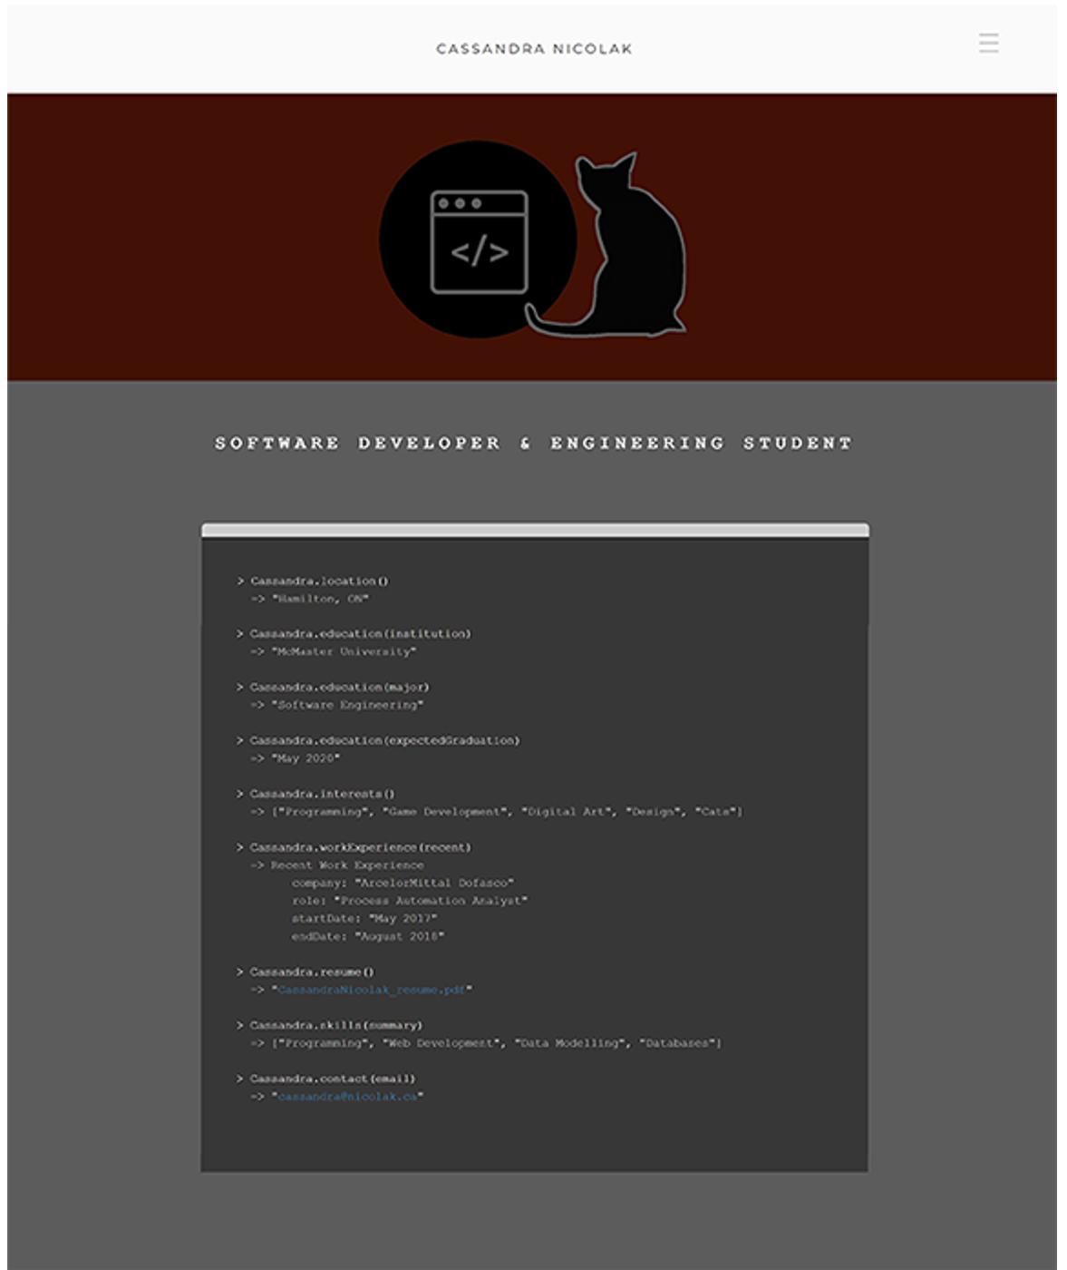

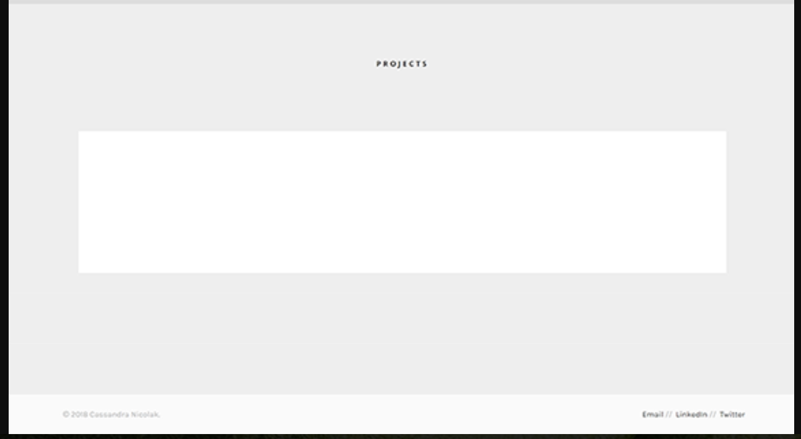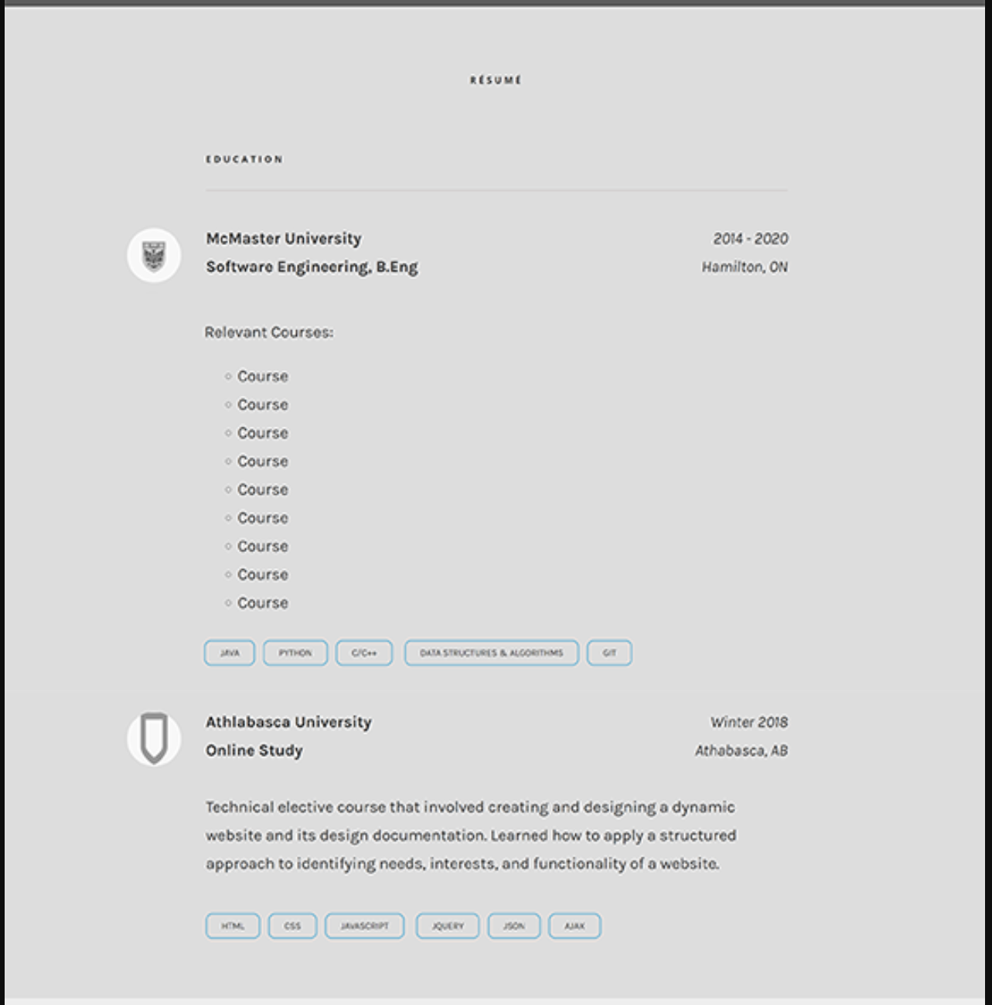

**APPENDIX B: Site Map**

**One-page Scroll:**

**APPENDIX C: Image Sources**

|  |  |
| --- | --- |
| **Reference** | **URL** |
| #1 | <http://www.sacredchristmas.net/wp-content/uploads/2018/03/professional-man-business-suit-dressed-harvest-life-changers-for-professional-business-photo-man.jpg> |
| #2 | <https://thegoodgreatsby.files.wordpress.com/2011/04/receptionist2.jpg> |
| #3 | <http://www.unibe.ch/unibe/images/content/e71418/e71448/e71449/iStock_000007384989Large_ger.jpg> |
| #4 | <http://www.collegequest.com/wp-content/uploads/how-to-become-a-software-engineer.jpg> |
| #5 | <https://www.razorrobotics.com/wordpress/wp-content/uploads/2017/02/build-your-own-robot.jpg> |
| #6 | <http://www.focusit.ca/wp-content/uploads/Young-Male-Intern-512x768.jpg> |
| #7 | <https://relyfeonline.files.wordpress.com/2018/01/img_20180125_182640.jpg> |
| #8 | <https://static3.businessinsider.com/image/5a46a11c4aa6b5f7188b7599-1200/web-administrators.jpg> |